**EC2 (Server)**  
These are cloud servers where our app runs.  
We create two sets — one called Blue, another called Green.

**ALB (Load Balancer)**  
This sends user traffic to the right server.  
We connect it to Blue or Green servers based on rules.

**IAM (Permissions)**  
It gives EC2 servers the right access.  
We use it so EC2 can connect to other AWS services safely.

**ACM (SSL Certificate)**  
It gives us a secure HTTPS link (with lock symbol).  
ALB uses this to make the website safe.

**Security Group (Firewall)**  
It controls who can access our servers.  
We open ports for internet, browser (80/443), and SSH (22).

**Terraform**  
This tool creates everything for us using code.  
We use it to build, destroy, and switch between Blue and Green easily.

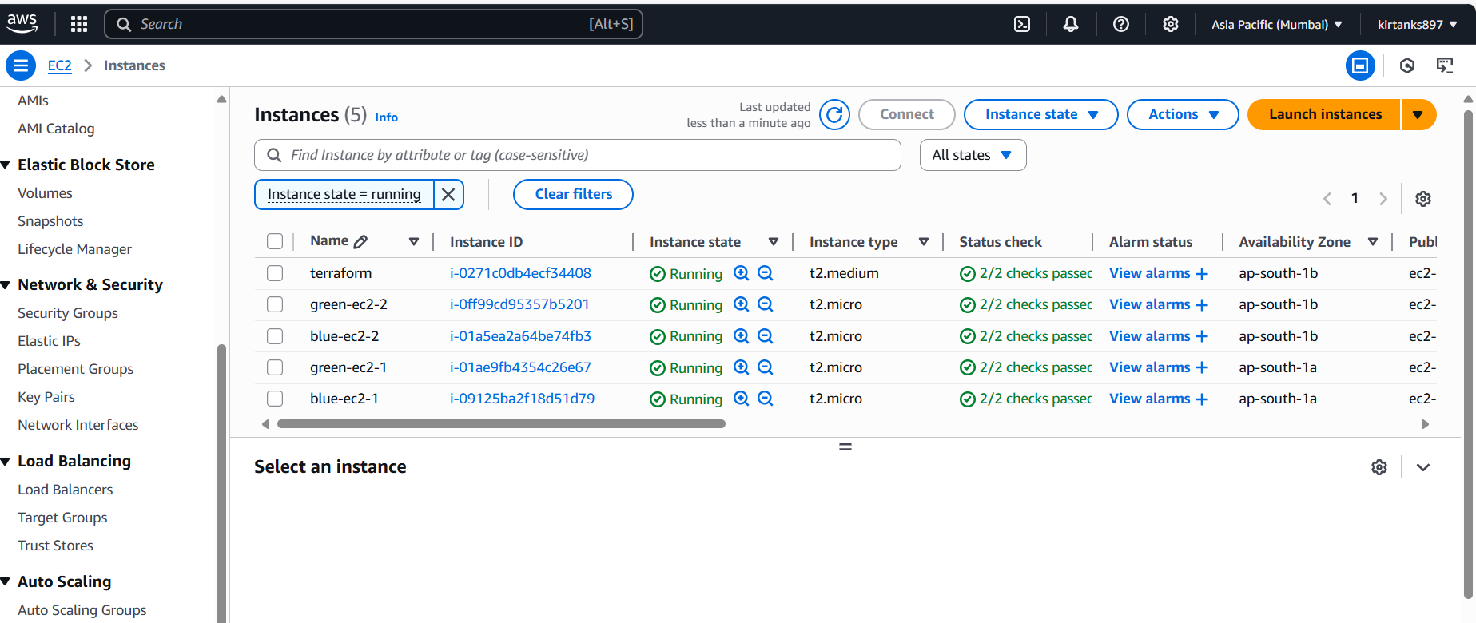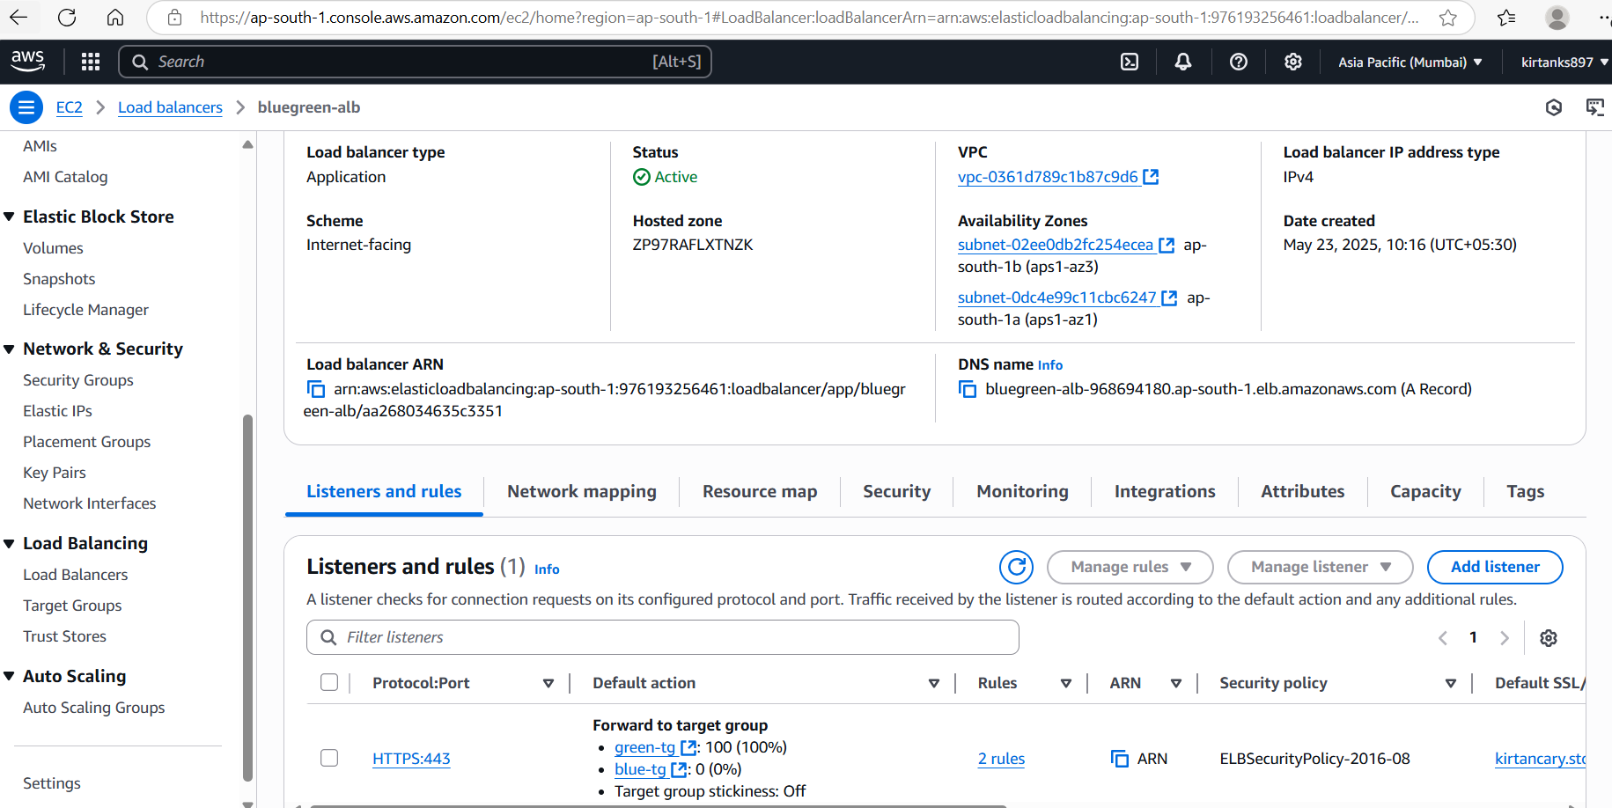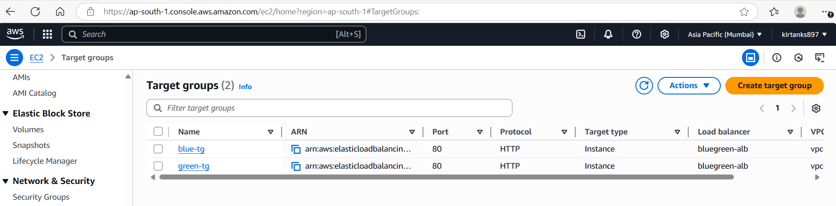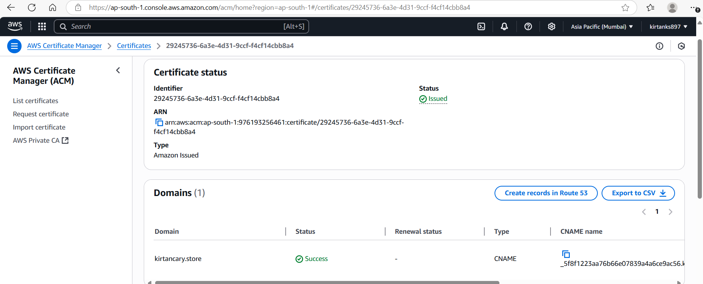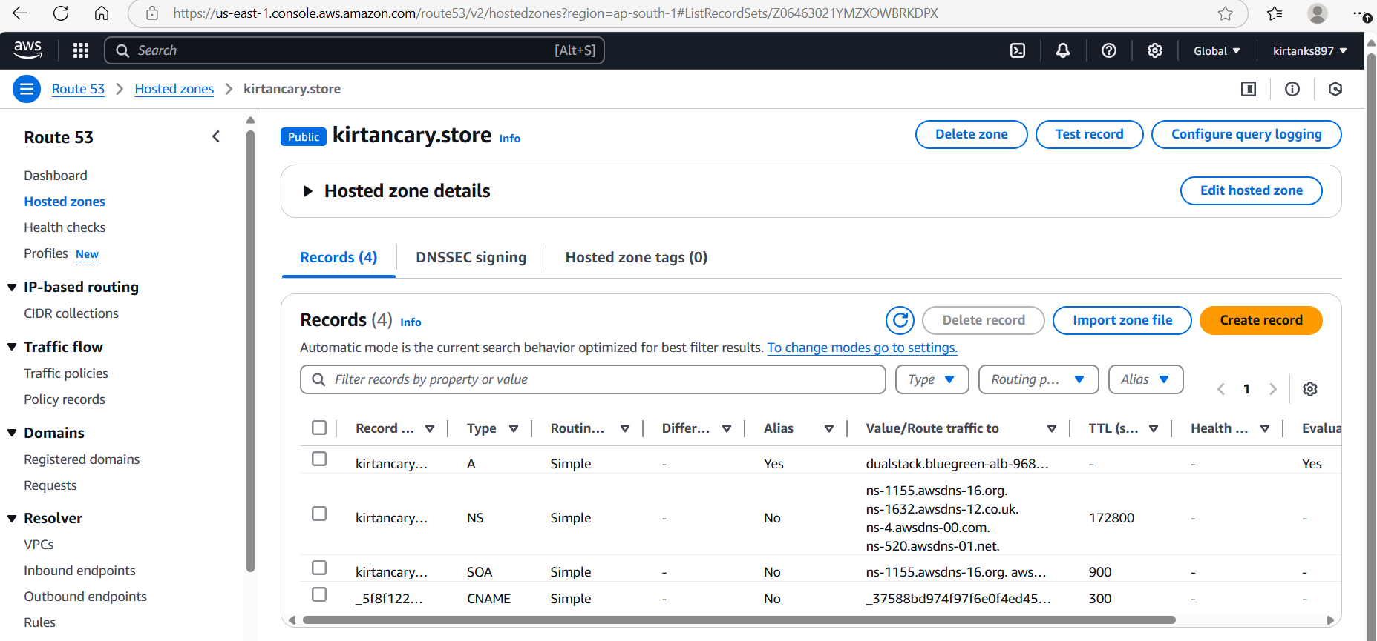

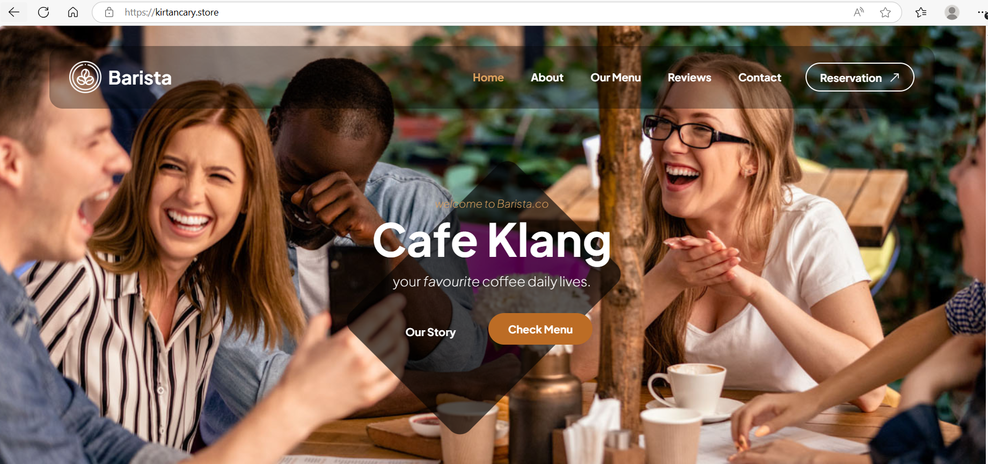

Blue Environmet

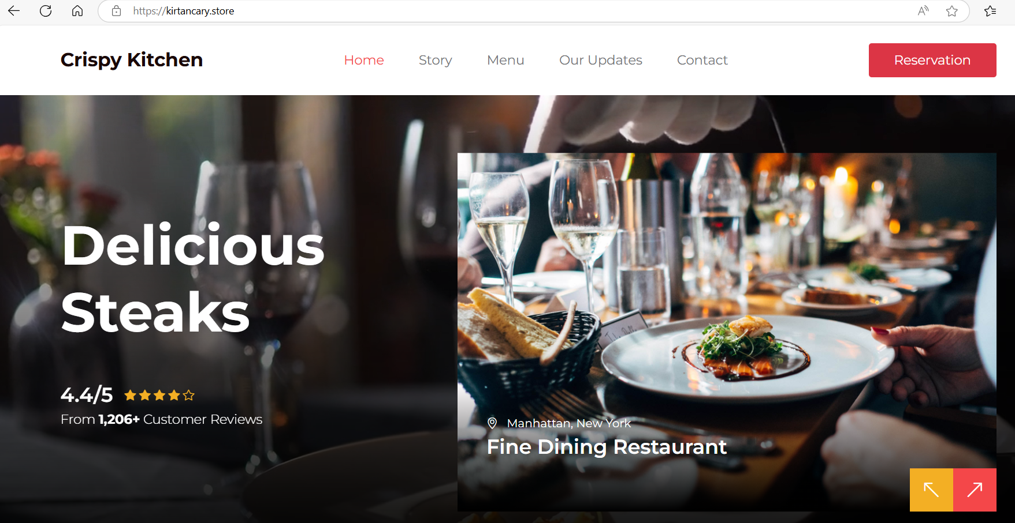

Green environment